1. 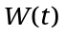is the amount of water (in ounces) in a pot t minutes after the water begins to boil.
Suppose W(2) = 30 and 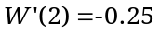

a. Give a sentence of practical interpretation for W(2) = 30 .

b. Give a sentence of practical interpretation for .

c. Find the percentage rate of change in the amount of water in the pot 2 minutes after the water begins to boil. Give units with your answer.

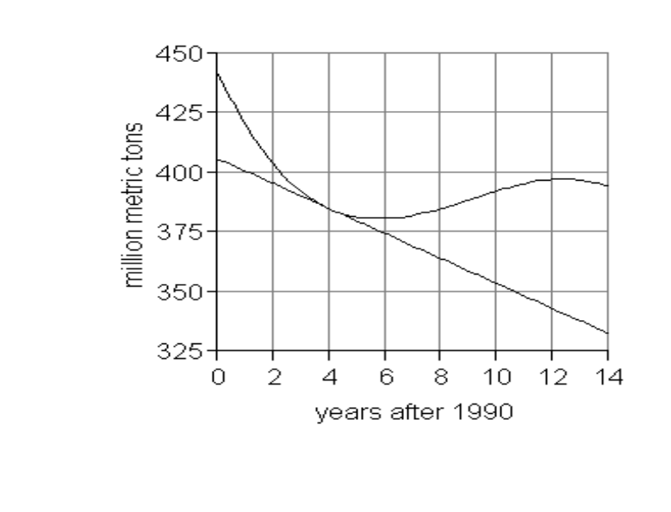
(2, 405)
(4, 384)
(8, 385)
(14, 334)
2. 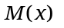depicts the world production
of milk (in million metric tons),
x years after 1990, 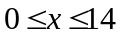.

a. Using a ruler, draw a line connecting the points at x = 2 and x = 8 on the graph. Find the slope of this line. Show all of your work.

b. Give your answer to (a) in a sentence of practical interpretation.
c. Find 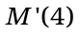. Show all of your work.

d. Give your answer to (c) in a sentence of practical interpretation.

3. The equation 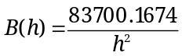 points describes the body-mass index (BMI) for women where h is a woman’s height in inches, 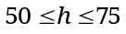. Checkpoint: B(51) = 32.180.

Use the Numerical Method to determine how quickly a woman’s BMI is changing when her height is 60 inches tall by completely filling out the table below.

Round table entries to FOUR decimal places.

Close points  To the left | Slope between 60 and Close Point | Close points  to the right | Slope between 60 and Close Point
59.9 | 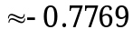

a. How quickly is a woman’s BMI changing when her height is 60 inches tall?

b. Find the percentage rate of change in the woman’s BMI when her height is 60 inches.

c. Write a derivative model for the function B(h):

4. Review the various types of change we have studied:

TYPES OF CHANGE | FORMULA | UNITS
CHANGE
PERCENT CHANGE
AROC
IROC
PROC

a. Fill in the second column of the table with the correct formula:

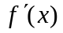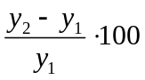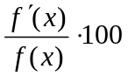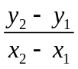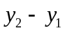

b. Fill in the third column of the table with the correct type of units:

Output units % Output units per input unit

Output units per input unit % per input unit

c. Write the type of change described in each sentence:

- In November 2006, the number of Facebook (unique) users was increasing by 2 thousand per month. ___________

- Between May 2006 and May 2007, the number of Facebook (unique) users increased by 89.4 %. ___________

- From May 2006 to May 2007, the number of Facebook (unique) users increased on average by 1.048 thousand per month. ___________

- Between May 2006 and May 2007, the number of Facebook (unique) users increased by 12.58 thousand. ___________

- In November 2006, the number of Facebook (unique) users was increasing by 12.5% per month. ___________

5. Find the derivative for each of the following functions. Use proper notation.
You will be penalized for incorrect use of “=” signs or for failure to use derivative notation for each derivative. If there is an algebraic transformation necessary, no credit will be awarded IF the transformation is not made.

a. 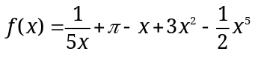 b. 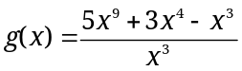

c. 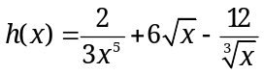 d. 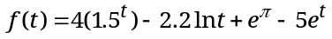

6. N(x) thousand gives the number of observed bacteria in a Petri dish, x hours after 8 am, between 8 am and 8 pm.

Use the fact that N(2) = 32.698 and the slope of the tangent line to N(x) at 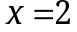 is 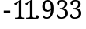, to find the percentage rate of change of N(x) at . Round your answer to three decimal places and include units with your answer.

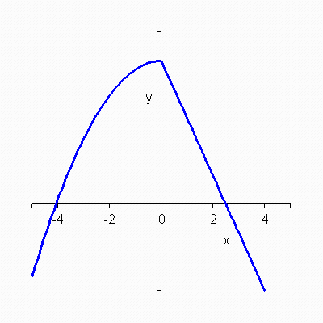
7. The graph of a function 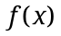 is given.

Which of the following is the graph of 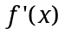?
a. b. c.
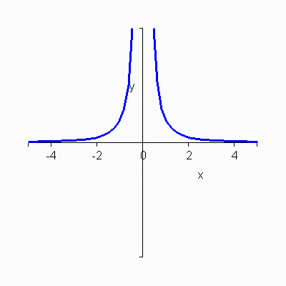
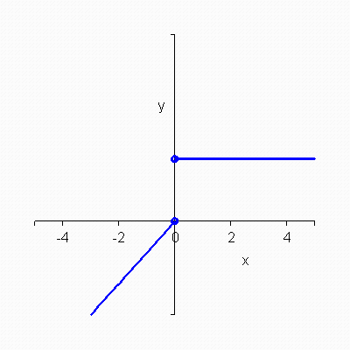
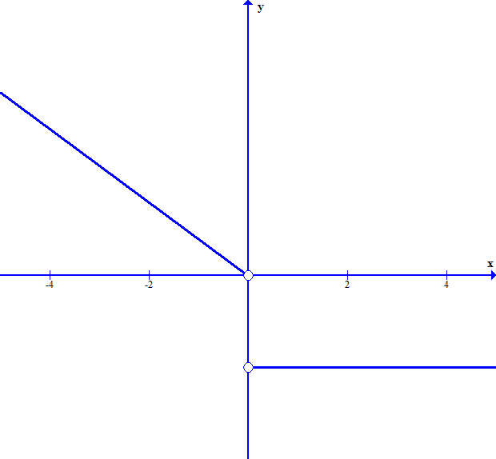

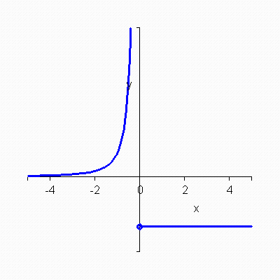
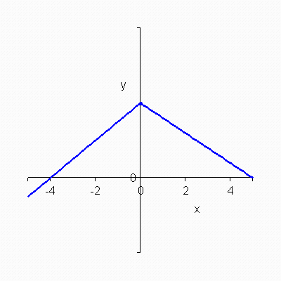
d. e.

8. When you use the Algebraic method (the limit definition) to find a derivative formula or value, you find 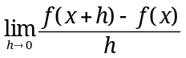. In this formula, what does the variable “h” represent, what does 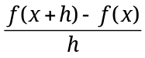represent, and what does the represent?

9. Given 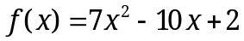. Show that 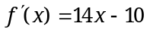 using the limit definition of the derivative. Show each distinct step and use proper mathematical notation in your work.

10. The statements below refer to the graph of 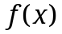given below. Which one of the following statements is true?
a. Line 1 is a tangent to. The slope of Line 1 gives the average rate of change of between point A and point C.

b. Line 2 is a secant on. The slope of Line 2 gives the average rate of change ofbetween point B and point D.

c. Line 1 is a secant on. The slope of Line 1 gives the instantaneous rate of change of at point C.

d. Line 2 is a secant on. The slope of Line 2 gives the instantaneous rate of change ofbetween point B and point D.
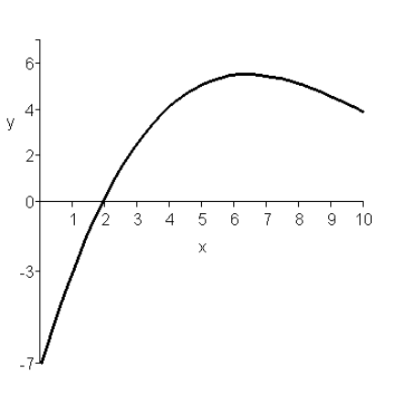
B
C
Line 1
Line 2
D

A
A
f(x)

11. 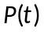people gives the attendance at an amusement park where is the temperature in degrees Fahrenheit. 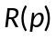thousand dollars gives the daily revenue for the amusement park where is the number of people in attendance. When the temperature is 85 degrees Fahrenheit, there are 5540 people in attendance at the amusement park, and the revenue is 149.580 thousand dollars.

When 5540 people are in attendance the daily revenue is increasing by $0.028 thousand per additional visitor. When the temperature is 85 degrees Fahrenheit the number of people in attendance is decreasing by 208 per degree Fahrenheit.

When the temperature is 85 degrees Fahrenheit, the park’s daily revenue is changing by ________ thousand dollars/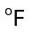,

a. -1.760 b. -208 c. 0.028 d. -4.188 e. -5.824

12. 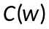pounds gives the yield of cantaloupes obtained from a particular field when w gallons of water are sprinkled daily on the field in the last two months before harvest. 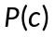dollars gives the farm’s profit after harvesting and selling c pounds of the cantaloupes. When 200 gallons of water are sprinkled on the field daily, the field yields 7,280 pounds of cantaloupes. The yield is increasing by 21.84 pounds per gallon of water at this level of sprinkling. When 7,280 pounds of cantaloupes are sold, the profit is $400. Profit is decreasing by $0.07 per pound when 7,280 pounds of cantaloupes are sold.

When 200 gallons of water are sprinkled on the field daily, how fast is the profit changing by _____________ dollars per gallon of water (sprinkled on the field).
a. - 1.529 b. 8226.4 c. 1.529 d. -509.60 e. 509.60

